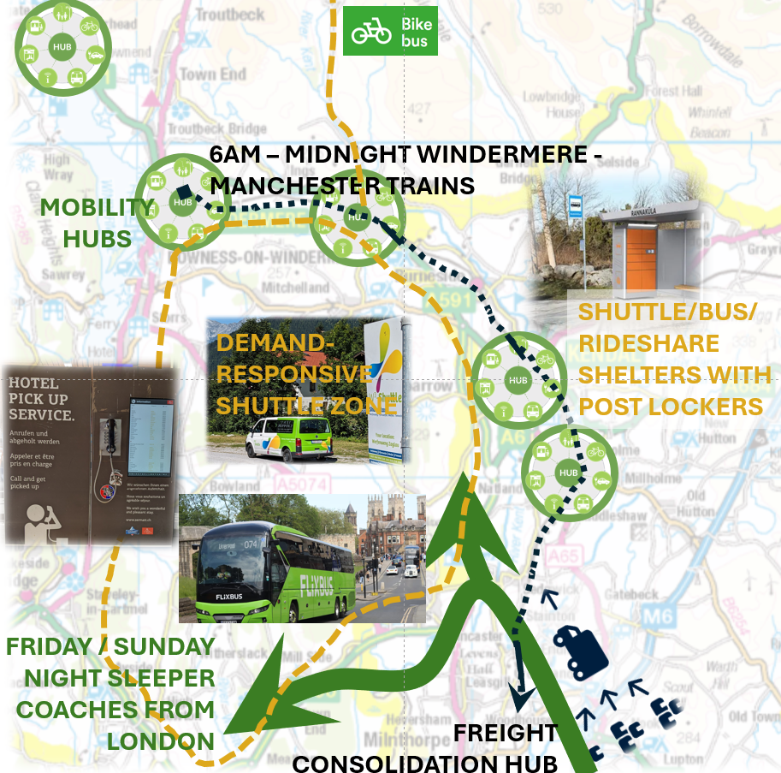 | What might carbon-reduced transport look and feel like in Cumbrian communities?  Alistair Kirkbride  October, 2025  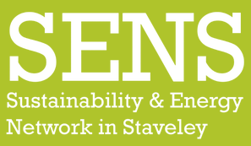  

Contents

1. Introduction 2
What’s the problem? 2
What does this project try to do and how? 2
2. Working out what low carbon mobility looks like at community level 4
2.1 Translating the transport & mobility Emissions Reduction Action Plan (ERAP) to reality 4
2.2 What are people’s priorities for low carbon transport? 5
2.3 What are residents thoughts for low carbon transport and their community and lifestyles in Grange and Staveley? 5
3. So what might low carbon mobility look and feel like? 9
Grange over Sands and the PEAT area 10
Staveley 19
Annexe 1: Transport & Mobility ERAP interpreted for Cumbrian localities 30
Annexe 2: Transport recommendation of the climate juries in Furness, Kendal and Copeland 34
Annexe 3: “So what might low carbon transport involve around here?” slides from Grange workshop 38

Summary

Introduction

What’s the problem?
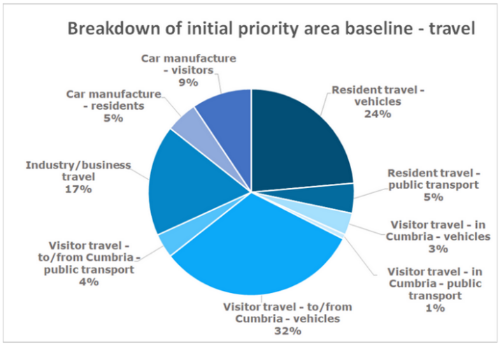
Transport is big slice of carbon budgets, both nationally (24%, requiring an 86% reduction 2023-2040) and for Cumbrian communities (28.3%).
Figure 1: Components of carbon emissions from transport in Cumbria (from SWC Carbon Baseline for Cumbria, 2020²)
Emissions reductions from the transport sector are proving elusive for a variety of reasons: people are driving less but cars getting bigger; like-for-like vehicles are getting more efficient, but next-day deliveries mean more delivery van mileage etc.
The Zero Carbon Cumbria Emissions Reduction Action Plan for Trasport & Mobility³ sets out 29 actions across 4 priorities. These are based on synthesis and interpretation of what is understood to be the interventions that together would be effective in making significant reductions in carbon emissions from transport and travel.
...so what is not happening?
A big gap is people understanding what low(er) carbon mobility might look and feel like for them, their lifestyles and places familiar to them; “Without a public engagement strategy for sustainable travel transformative change is unlikely, perhaps impossible”
Without this, it is difficult for
- People to aspire to lower carbon transport – as it is poorly specified and not connected to their specific lives
- Meaningful discussions to be had on changes to the transport system – the building of consensus and/or informed, respectful dissent
- Communities to engage meaningfully with decision-making bodies on strategies for change, and hence for decision-making bodies to develop priorities aligned with community-scale appetites for meaningful decarbonisation of transport.

What does this project try to do and how?
“Although there are many technological solutions and policy approaches for transitioning to a fossil-free society, effective action is still lacking. We need a new way to address the issue, one that inspires and attracts the widest possible group of society”¹

This project aimed to
- Distil knowledge (about what needs to be done to decarbonise transport in Cumbria) and translate it to questions and challenges that make sense for residents thinking about their lives, communities and neighbourhoods
- Explore with residents how their lifestyles and neighbourhoods might be like if they were compatible with net-zero transport
- Reveal how far local people are able to understand how their familiar places and their lifestyles might be with net-zero compatible transport behaviours and systems
- Reconcile strategic priorities for transport & mobility decarbonisation (carbon budget, ERAP) with residents’ appetites and ambitions
- Describe what net-zero-compatible mobility looks like for two communities – Grange-over-Sands and Staveley. This is the main purpose of this project
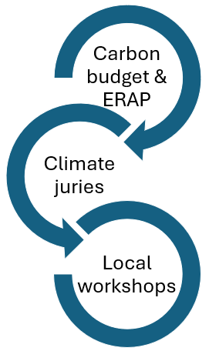
It does this by combining three main sources of ideas:
- The carbon budget for Cumbria and the Emissions Reduction Action Plan.
The carbon budget identifies the sources of carbon for all activities across Cumbria. The emissions reduction action plan (ERAP) develops 29 actions in 4 themes that are identified to lead to meaningful reductions in carbon from transport. These are also informed by external policy and ideas – such as the required scales of traffic reduction and shift to public transport.
- Climate juries
We summarise the nature of transport interventions identified by three local climate juries: Furness, Kendal & Copeland. The purpose is to indicate the sorts of interventions identified by cross-sections of the public through well-informed deliberations.
- Local workshops
This project engaged with communities in
  - The Furness peninsula area (Grange-over-Sands – Cartmel – High Newton) via the PEAT (Peninsular Environmental Action Together) group
  - Staveley area – via the SENS (Sustainable Energy Network Staveley)

Working out what low carbon mobility looks like at community level

2.1 Translating the transport & mobility Emissions Reduction Action Plan (ERAP) to reality

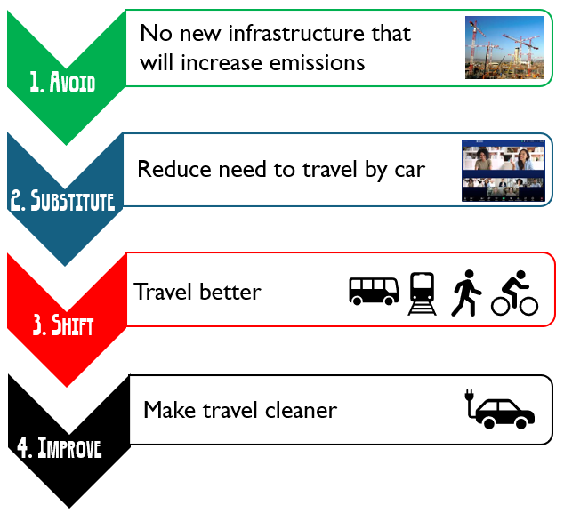
Introduction to the ERAP
The Transport & mobility ERAP was developed by a broad working group as part of the Zero Carbon Cumbria programme between 2022-2025. It structures interventions through four themes as shown on the right. Each of these themes comprise specific actions. There are 29 actions in total.
What the ERAP does not do is to set out required intensities of change – what percentage of traffic reduction? How many more bus journeys per week per person? (etc). Here, we also assume the following:
  - Traffic will be 20% less in 2030 compared to 2019
  - There will be over 10 times the number of public EV charge points by 2032
  - Buses:
    - On average, each person will make two extra bus trips per month. As many people currently never use the bus, this would feel like a significant change for the majority of people
    - Bus services will increase by 40% on average; in areas with very poor public transport, meaningful service levels would feel like a significant difference
  - Road speeds will be decreased: 20mph as standard in residential areas; 40mph or 50mph on most roads, 60mph on trunk roads and motorways
  - Road user charging would be comprehensive with demand pricing for busy times / busy places

The main audiences for the ERAP(s) are the partner organisations that have appropriate influence, powers, responsibilities or abilities to take ownership and deliver the actions - not (primarily) local communities.
An early part of this work set out to find out whether and how the ERAP actions as ariticulated made sense at community level. Indeed, a key aim of this study was to apply them at community level in order to develop clearer pictures of what resulting places and lifestyles might look and feel like – as a way of engaging and motivating public action and – more generally – nurture greater civic support for net-zero-compatible access and transport.
It became clear at an early stage that the actions were very difficult for local residents to apply meaningfully to their locality.
Instead:
- As a desk-based exercise, the ERAPs were interpreted with regard to pragmatic actions that (i) make sense with regard to lifestyles and places that are relevant to the participating Cumbrian communities and (ii) were then used to “design” places and lifestyles that might be compatible with net-zero ambitions. These are given in Appendix 1.
Here, we interpret actions that are appropriate to the two specific communities (Grange and Staveley) and their surroundings.

What are people’s priorities for low carbon transport?
Climate juries – Furness, Kendal, Copeland
Climate juries (or “people’s panels”) involve a balanced cross-section of a community to develop understanding and discuss one or more specific questions with the intention to come develop recommendations that are both meaningful and relevant to the local community. These were done in three areas locally (Furness – centred on Barrow, Kendal and Copeland) in 2021-22. Each of these identified recommendations for transport; these are set out in Appendix 2.
` There is a lot of detail in these recommendations and the ways that similar ideas are articulated by the different juries make it difficult to summarise the recommendations here, except for the strong overall support for better public transport, better conditions for cycling and walking and better opportunities for the use of low- or zero-emission vehicles. A core observation is that there is overall compatibility between the jury recommendations and the ERAP; put another way, the ERAP covers all of the main ideas that emerged from the juries.
Complementary to the climate/citizens juries is a piece of research on Appetites to travel differently in the Lake District (2024). Using a variety of sampling methods, this research aimed to gauge general appetites for the future of transport in the Lake District separate to immediate concerns; it targeted residents and visitors as well as people who were more and less familiar with the Lake District. The headline findings were that people want less traffic, better (integrated) public transport, better conditions for cycling and certain restrictions to free access by car.

These findings are taken into account in designing the local plans as set out in section 3.

What are residents thoughts for low carbon transport and their community and lifestyles in the Grange area and Staveley?
This works focusses specifically on the two settlement areas of Grange-over-Sands / Cartmel peninsula and Staveley area. It is well known that asking people “blind” about ideas on envisioning lower carbon travel is not productive; whilst the public might be aware of general ideas, the ability to translate these to familiar places and their own lives is too complex and involved for most people.
Here, we took two different approaches to the two localities:
Grange/Cartmel peninsula: core ideas and illustrations of low carbon transport were presented using images and questions in ways that then allowed residents in a workshop to apply them locally.
Staveley: findings from relevant recent engagement exercises (mainly the 2024 SENS I Get Around research plus the 2009 SENS Staveley GTI action research project) were mined and the relevant findings incorporated with the ERAP and jury ideas to inform a Staveley locality low carbon access & transport plan.

Grange & Cartmel peninsula (via PEAT (Peninsula Environmental Action Together) group)
A workshop was designed to allow residents to explore what low carbon transport might mean for them – their own specific “mobility” lifestyles and places that are familiar to them. It was a drop-in event over a whole day as part of the Big Green Week (June 2025). There were two points in the day where it was advertised that the ideas would be introduced, but people were able to come and go when they pleased. About 28 people took part over the whole day.
The workshop involved three interactive parts: mobility lifestyles, re-designing transport and re-designing places. These were introduced in this order in order to try to “root” participants in their own experience and gradually introduce ideas to inform their thinking.

a. Mobility Lifestyles

This exercise was designed as a warm-up exercise - to invite people to think about their own “mobility lifestyle”.
The purposes were:
- To try to get them to think about what transport decarbonisation would look like from their own perspective – to try to start from people’s lived reality – not in terms of principle or “what I am supposed to think”
- As a primer - to introduce this exercise before asking questions about their views on specific issues on transport (modes etc) or place – so that they might be better prepared to consider these questions from their own lifestyles.

The exercise involved three stages
- A guided set of questions about their existing “mobility lifestyle”

Participants were asked to fill this in as best as they could – so that it roughly described their lifestyle

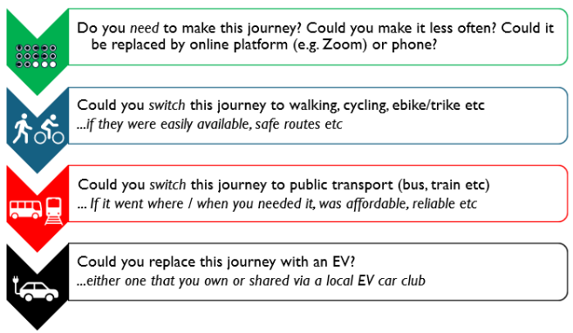
- A sequence of four steps about how to decarbonise how we travel.
These were designed to follow the ERAP’s structure of
  - Reduce the need to travel (by car)
  - Travel better
  - Make transport cleaner

Participants were asked to read these and consider the questions...
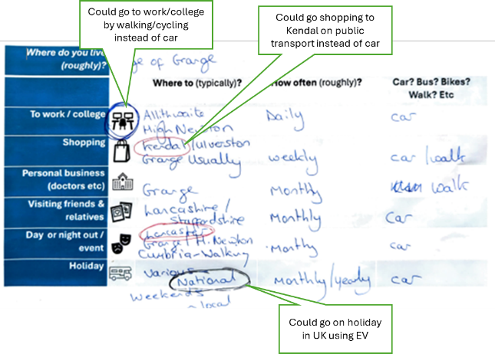

- ... then using appropriately coloured pens, to go back and circle or edit their own mobility lifestyle (stage 1)

b. So what might low carbon transport involve around here?
This part encouraged people to “let rip” to design what they think would make a low carbon transport system. As it followed the mobility lifestyles exercise, the idea was to make sure that people tried to relate their suggestions to their own lives.
It used 7 large (A1) posters designed to let people write on them – notes, lines, comments, comments on others’ comments etc (thumbnails in Appendix 3). There were two types:
- Themes posters – on “Getting here and away”, “Getting around locally: public transport”, “Getting around locally: walking, cycling, wheeled”, “Getting around: shared transport” and “Mobility hubs, streetscape and parking”.
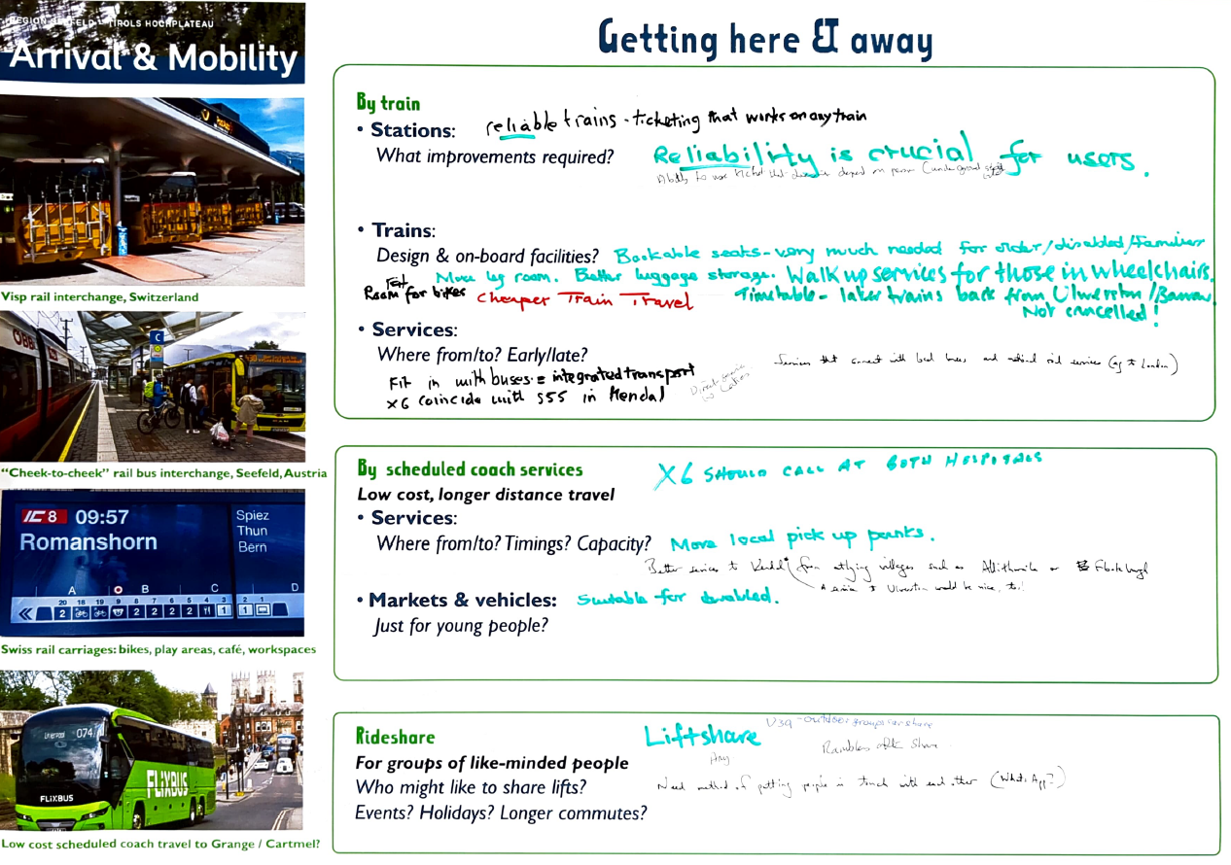
Each poster included relevant images chosen to illustrate what “good” looks like elsewhere, and a series of boxes and prompts to help people interpret these relative to their local area.
- Maps at 2 scales – north-west England and the PEAT area (not shown in Annexe 3).
These allowed people to talk about possibilities, share experiences and opinions about what currently works well or the limits of the current transport system, and – importantly – capture their thoughts by writing on the posters.

How would you redesign local places to make “getting around” work better, reduce emissions and be more attractive?
This part was all about re-designing familiar localities. Again, it used large posters and invited people to write on them.
We chose four localities: Grange (station & forecourt & Main St parade), Grange centre, Cartmel & its immediate environs and Cartmel village centre.

The ideas contributed via this workshop were incorporated in the net zero mobility schemes set out in section 3

Staveley area
Discussion among SENS colleagues following they Grange workshop led to view that
- a similar workshop would not currently work well in the locality.
This is partly because of the risk of engagement overload; in recent years, cross-village engagement exercises have taken place for the Community Plan, the SENS I Get Around project¹², development of the community ebikes scheme and an ongoing PC survey reviewing residents car parking.
- There is already rich intelligence on Staveley resident’s views on their openness to different ways of getting around and use of transport services. In particular:
  - The Staveley GTi (Green Travel initiative) project (2009) was an action-research project involving personalised travel planning for Staveley residents. These plans were followed through to help people use different types of services and led events such as “bike train” cycle commute pods as well as setting up new services such as the village car club.
This gave a good idea generally on local views on buses, trains, car parking, cycling etc across a broad cross-section of the village residents.
  - The CommunityEbikes project¹⁴ (2023 -) involved co-designing a pay-as-you-go ebike scheme for the village. This high-profile scheme developed following extensive and ongoing feedback across a variety of community networks and events.
This project engaged with types of people who do not normally link with “transport” or “environmental” engagement. It has provided insights into the openness to travelling differently – particularly by ebike and cycling more generally – of people within the village.
  - The I Get Around project¹² (2024-) set out to understand barriers and solutions to people “getting around” locally.
This has been useful to set out community-led ideas on the types of improvements people would like to see on the ground (main infrastructure ideas are reproduced on p26) as well as people-led initiatives such as to make lift-sharing easier and developing “volunteer accompanier” networks.

So what might low carbon mobility look and feel like?
Here, we describe how things might look and feel in two ways:
- Lifestyles
Descriptions of everyday life of a few types of people - going to work, trip to an eye appointment, weekend away…
- Places
Annotated maps are used to suggest how places might look different, how they might be laid out etc
They are presented a lifestyles then places as places then make more sense.
…and what is a mobility hub or personal travel account? There’s a glossary summarising all these after the descriptions.

These are informed by the ideas from the sources in the previous section. Not all ideas in the previous section make it explicitly into these descriptions – their purpose is to give an idea of how things might look and feel – what everyday experiences might be like.

Grange over Sands and the PEAT area

Lifestyles

Family
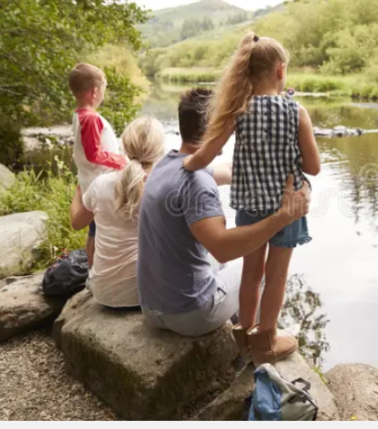
One full time work parent (teacher, Ulverston), parent with pre-school child, child at primary school; live on Charney Court, Grange
Getting to work/school
Phil decides to take the train today to get to work. He uses his mobility account – which means he could choose between the train, bus, village shared EV or ebike – all charged back to the account, but today, the train makes sense. He pays for his account in the same way as he does for his phone, broadband and other utilities – on an account that works best for him.
Alice – at year 5 – is now a helper on the walking bus to school – which is gloriously rowdy this morning. She “catches” it at the end of Charney Court with a parent-helper then pick up people along the route. The pavements are wide, the crossings, the traffic slow and respectful. She gets to school energised and ready for her day.
Today is playgroup day. Katie walks to playgroup. The pavements are wide, crossings in the right place with build-outs so that the road is narrow at the crossing with and no kerbs. The shared space schemes have transformed the village centre. After playgroup and local café trip, Katie has booked one of the village EVs to head out with a couple of her mates and their kids to go for a swim on the quiet east shore of Coniston. There’s a few of them with quite a bit of baggage so they take a larger car, picking it up from the mobility hub outside the station where she’ll stash the pushchair. This is booked via her mobility account with the costs automatically split with her friend’s accounts.
Delivery
While she’s out, Katie gets a message to tell her that she has a parcel to pick up. After dropping off the car back at the station, she walks across to the MailHub, scans her QR code and a locker pops open and she picks up her parcel – gone are the days of endless failed deliveries and having to stay in. It’s great to see that the station area blooming again with all this activity.
Day/night out locally
It’s barbeque night – in High Newton village hall and the kids are keen to go because many of their mates are going. In the afternoon, Phil books the shuttle. At 7pm, an alert says that the 16-seater will arrive at the end of Charney Well Lane on Hampsfell Road at 7:11. Tonight, it’s already picked up a family from Lindale and has two more stops on the way – a couple just outside Cartmel and someone from a farm near Broughton. Phil and Katie look forward to having a good chat with mates with a beer or two followed by a good night’s sleep.
Away for the weekend
The forecast is great for the bank holiday weekend, so they are heading off to Coylumbridge in the Cairngorms. Their camping gear is packed and picked up on Wednesday evening as the add-on to their train tickets. On Friday, they get the train to Lancaster for 10pm to pick up the sleeper. The kids love the adventure of sleeping on a train and they are gently rattled to sleep heading north. They decide to get breakfast in Aviemore, then take the shuttle to the campsite. They check in, pick up their bags, get the tent off and they’re off…
Professional couple
Ed often has meetings in London or Edinburgh, Julie is a peripatetic social worker. They live in Cartmel.
Getting to work
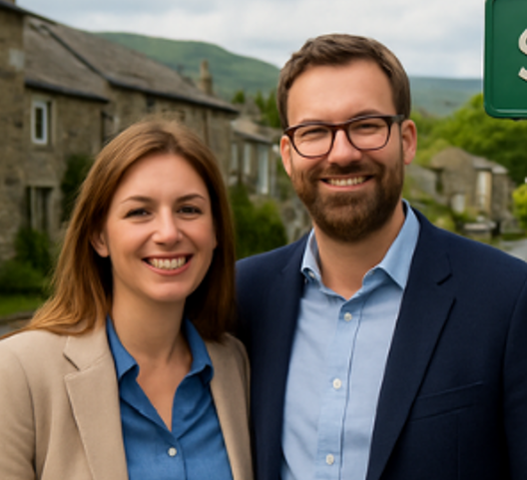
Julie’s job means that for 3 days per week she is visiting clients in the homes in the South Lakes area. She takes a shared EV from the village hub most of the time, otherwise heads into Kendal or Barrow on the train or bus to the office.
Ed works mainly from home. This often involves breaking the day going for a run or heading to a local café, either with a laptop or just for a chat.
Tomorrow he has a meeting in London. It’ll be the first time he’ll have met the clients face-to-face and is looking forward to it. OK, the bike ride to the 06:10 train from Cark will be a bit of a shock, but one change and then in London for 9:15 is pretty good. He booked it via his mobility account, designating the journey to work so he doesn’t have the faff of and expenses claim. He has an early videocall at 8 so she booked a pod in the work coach for 8-8:30.
Shopping
Ed breaks his day today by picking up the shopping over lunchtime from the mobility hub locker next to the school. Beforehand, he swings by the local shop to get fresh stuff, then picks up one of the e-cargo bikes from the hub to get all the shopping home. It takes a while longer because he keeps bumping into people for a chat, so as a result, he decides that that’ll have to do for today’s exercise. Julie has asked if he’ll pick up a delivery for her that has been in MailHub locker for a couple of days.
Holiday
Now September has hit and places are a bit quieter, they are heading off into the Lake District for a week. They’ve roughly plotted a route around the passes rather than the fell tops – as Ed pointed out that there are more pubs and café’s in the valleys than on the summits! They are mixing walking the bits with great paths with buses, boats and possible bikes to fill in. They’ll have to couple of supplements on their mobility accounts for some parts, but it’s great that they can go with a rough plan and work things out along the way

Single parent

Lives in High Newton, works part time at Newby Bridge with some weekend work in Cartmel
We’re part of the ParentShare lift scheme, so Jess gets picked up at about 8:15 most mornings for school. I do either one or two lifts per week. Depending on my shifts, I normally take the Work Shuttle or bus to Newby Bridge but today I’m taking the car. I don’t like putting miles on the car if I can help it. If I have shifts in Cartmel at the weekends, I’ll either take the D2D shuttle or drive. I have cycled in the past, but it’s just not for me!
Today, I’ve arranged for a shopping delivery to Newby Bridge, which is why I’m in the car. It’s so much easier than trailing to Ulverston, Barrow or Kendal to do a big shop – it just kind-of appears by magic. As I’m out most days, having it delivered to the hub at work is so much cheaper than paying for an evening delivery slot at home.
We’re off to see my sister in Manchester at the weekend. I only have a basic mobility account because of my need to use a car quite a bit, but it still gives me a great deal for trips like this. Jess & I will work out what games we’re taking and get some “trip food” (as Jess calls it), I’ll knock off on Friday, get the D2D shuttle to Grange, jump on the direct train and relax! It might only be a couple of days, but the train, trip food and maybe a sneaky gin, then arriving right in the centre of the city and it feels like a real holiday.


Elderly couple, one effective carer for other who has limited mobility
Jane and Jeff have lived in a bungalow near Field Broughton since they retired 22 years ago.
Jane has an appointment at the opticians in Ulverston this morning. She’s had a bad night but decided not to cancel – she knows that getting out is what she needs to do. However, she asks Jeff to cancel the door-to-door bus and take a village car instead – as Jane’s just not up for small-talk on the bus today. Also, if things perk up, they might head back via Jane’s sister near Torver, so it gives them some flexibility.

Tomorrow night, Jeff is heading to his singing group in Lowick village hall. He checks the time that his regular door-to-door bus booking will pick him up. It might only be a few miles away, but it’s anything but direct. Given that it gets dark by 6pm at the moment, it’s a godsend that the D2D service exists – no more driving at night to get to social events, which means that they are far better attended than they used to be. Jeff also says that the event basically starts as the bus arrives – and he sometimes hears the signing before it swings around the corner. As the bus also picks up for those heading to the Haverthwaite scout group, their repertoire is getting pretty wild – English folk meets Olivia Rodrigo!

Jane has started looking at options for a short break in the spring. They fancy south Wales or Devon to see the spring flowers. Their days of taking the coach are probably passed, so these days they choose to pay the supplement on their mobility accounts to take the train and use the luggage transfer service. The mobility guarantee takes a lot of the worry out of missed connections as they know that there will always be a solution, and it’s not for them to work out how to sort things out. Because it’s a holiday, they decide to book a taxi – just for them – to get to and from Grange.

Teenage friendship group from Flookburgh and Allithwaite who go to school in Cartmel
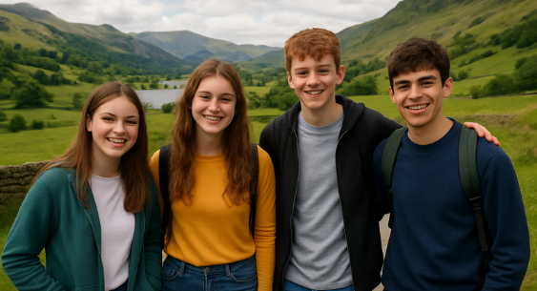
So we use our cards to just, you know, get around and hang out. It’s free for us which helps I suppose. It’s great that we don’t really need to plan much – we can just decide what were gonna do and use the app to work out how to get there.
Apparently it’s not long ago since we’d have had to buy a separate ticket for the bus or train or whatever, or go through that whole faff of trading chores at home for a lift from our parents. Well that’s all gone.
Getting to school’s pretty routine on the bus, but if say we stay on in town after school, we’ll sometimes get the D2D back.

Next weekend, a load of us are off to Leeds festival. We’re got seats on the FlixBus that we booked as an add-on to the tickets, so it was only a fiver each way. We’ll use our accounts to get to Lancaster then pick up the coach from there.


Cartmel village based food production business
It was a cracking spring day so I ran into work this morning from Kents Bank. I knew it was going to be a busy day so got some exercise in beforehand.
It’s Wednesday so it’s delivery day. The village businesses bulk their last-mile deliveries that aren’t urgent from the Shared Logistics Hub, mainly because of cost (if I’m being honest), but also to limit the number of vans clogging up the roads. More urgent stuff either comes to the door or into the village MailHub.
I’m out seeing clients for most of the day – Ulverston, Millom then a couple of stops in Eskdale and Seathwaite. I’ll do the first part by train then I’ll pick up an EV in Millom to get to the outliers and drop it back off in Kents Bank later on. I’ll book and pay for everything on my mobility account making sure I tick the box to charge it to the company. If I have time in the afternoon, I might take a bit of a detour for a swim in the Duddon.

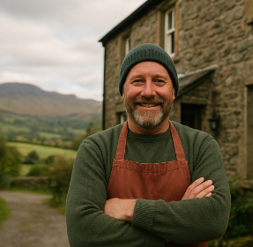
Visitor accommodation
We opened the Cartmel boutique hostel in response to the demand for a wider variety of accommodation types in the area. With the seasonal campsite on the racecourse, accommodation from economical to gastro in the village’s pubs, 3 guest houses and the SpareRoom network has really boosted the village as a destination for people to stay rather than just visit for the day.
About half of our guests have been before and after the first visit, most now arrive by train or coach then get the shuttle. Quite a few are booking the e-mobility add-on to their train ticket when they book their accommodation – so they hop off the train at Cark and jump on to an ebike or e-cargo bike. I’ve seen the amount of stuff that some people arrive with on the campsite – and wonder if they are staying for a month!
Our guests really value the ability to get around. It’s always been fairly easy to get along the main A590 and A591 corridor, but the shared e-mobility options plus the D2D shuttles have opened up the places people come here from the coast to the hills beyond High Newton, totally changing the visitor proposition. On top of this, the combination of the GuestCard, cracking real-time info and mobility guarantee has made getting around really simple and stress-free – it means people can explore on their terms rather than being pushed to the easy-to-access honeypots. This is great for means they stay longer! I especially like autumn as happy guests turn up with damsons and cheese that they have bought from the FellFarmVend points around the area.
The Work Shuttle system has opened up a much bigger pool of staff for the whole accommodation sector in the area. As an employer with a need for staff early & late in the day, the ability to have a say in shuttle routes and timings with other employers has been a game-changer. It means I can access a much larger pool of staff compared to the old days, I have happier staff and therefore we have a much more stable workforce.

Gourmet visitor weekend
We booked our meals for two nights plus accommodation and travel all via the first restaurant’s website – it was so easy.
It feels like a real luxury. We take the train after work from Picadilly direct to Cark where we’ve pre-booked the shuttle to the pub where we are staying in Cartmel as part of the ticket. Last time, we met three other groups on the shuttle all with similar ideas for a weekend of great food and exploration.
On Saturday, we decided to take a couple of ebikes to High Newton to build an appetite for lunch. Without a car, there’s no endless negotiation as to whose turn it is to drive so we can share a bottle with the meal. After a couple more great meals, we arranged for our luggage to be delivered to a locker at Grange station then had a great walk over Hampsfell on Sunday afternoon. After a well-earned pint, we hopped on the train back to Manchester, happy, refreshed – and a bit full.

Places
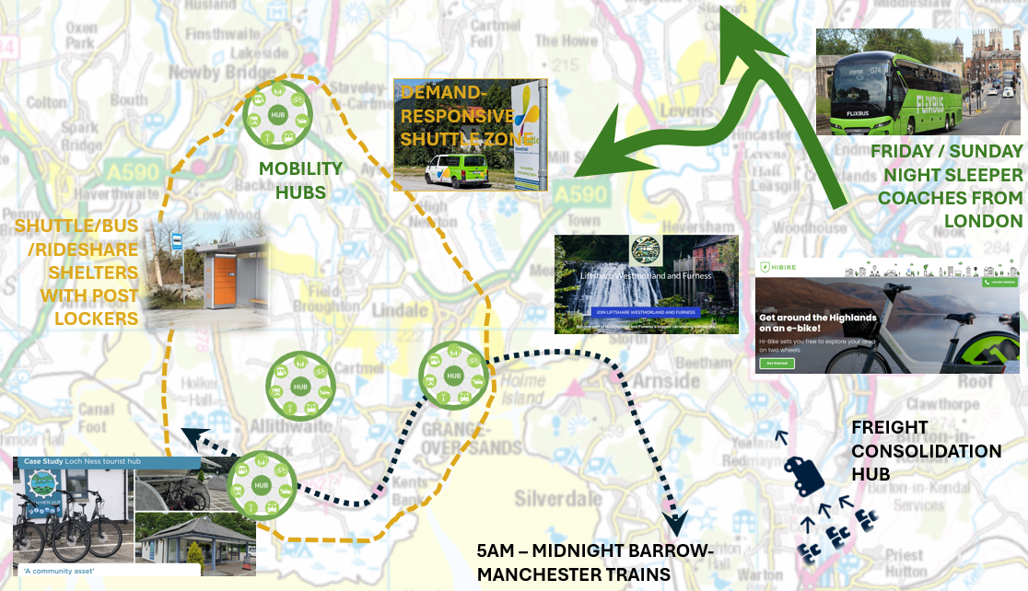
Grange rail station area & Main St
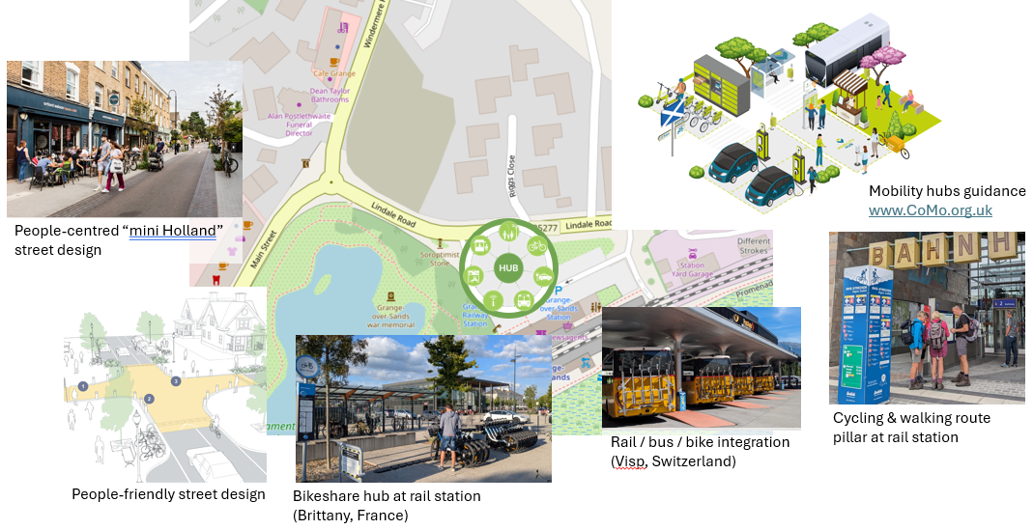

Grange centre 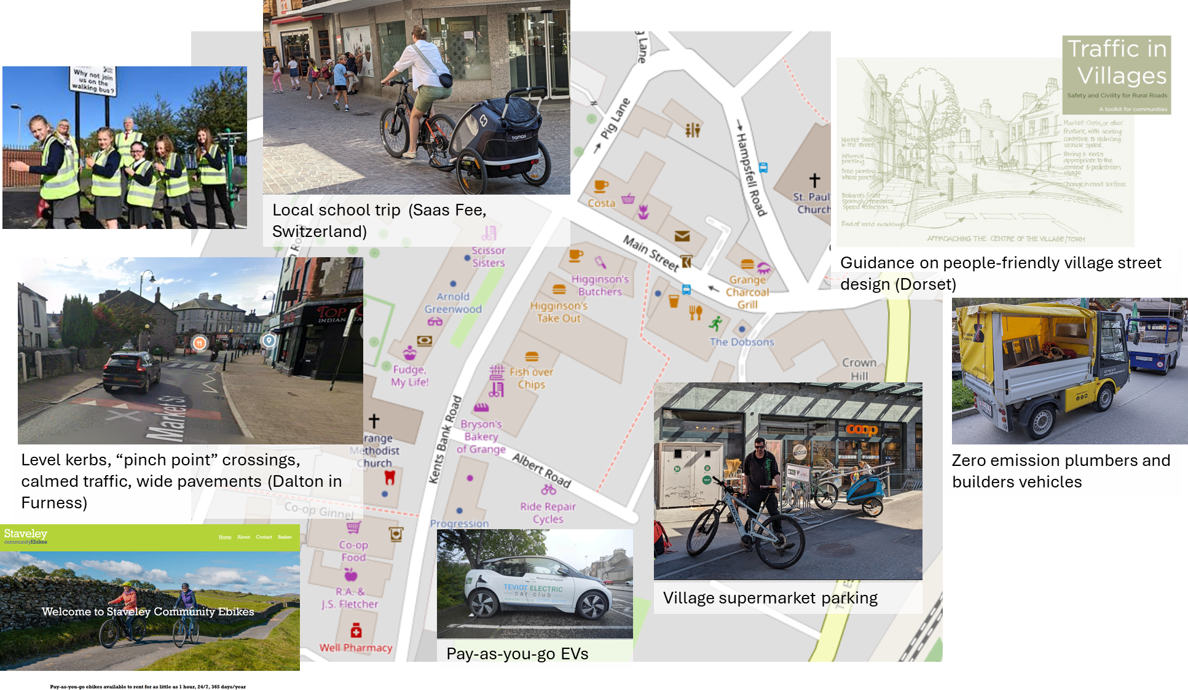
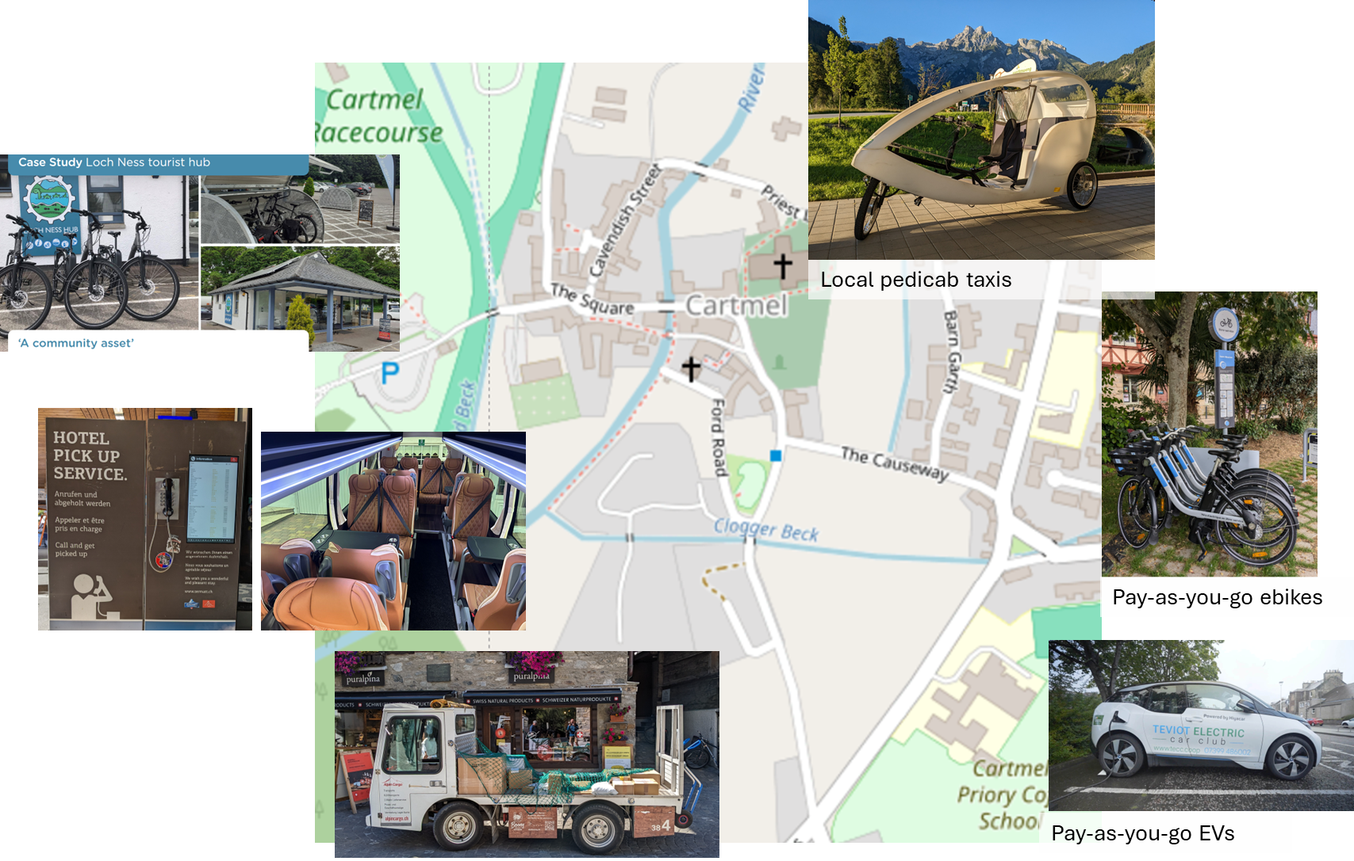
Cartmel

Staveley

Lifestyles

Family
One full time work parent (teacher, Kendal), parent with pre-school child, child at primary school
Getting to work/school
Phil decides to take the train today to get to work at QKS. He uses his mobility account – which means he could choose between the train, bus, village shared EV or ebike – all charged back to the account, but today, the train makes sense. He pays for his account in the same way as he does for his phone, broadband and other utilities – on an account that works best for him.
Alice – at year 5 – is now a helper on the walking bus to school – which is gloriously rowdy this morning. She “catches” it at the end of Beck Nook. The pavements are wide, the crossings easy – especially the shared space at the bottom of Station road and across Abbey Square, the traffic slow and respectful. She gets to school energised and ready for her day. After school today, she’s going to a friend’s house so will walk with her friend across the Big Field path.
Today is playgroup day. Katie walks to playgroup. The pavements are wide, crossings in the right place with build-outs so that the road is narrow at the crossing with and no kerbs. The shared space schemes have transformed the Station Road – Banks junction and the Pavillion square. After playgroup and local café trip, Katie has booked one of the village EVs to head out with a couple of her mates and their kids to go for a swim on the quiet west shore of Windermere. There’s a few of them with quite a bit of baggage so they take a larger car, picking it up from the mobility hub in the village centre where she’ll stash the pushchair. This is booked via her mobility account with the costs automatically split with her friend’s accounts.
Delivery
While she’s out, Katie gets a message to tell her that she has a parcel to pick up. After dropping off the car back in the village, she heads to the MailHub in the Beehive, scans her QR code and a locker pops open and she picks up her parcel – gone are the days of endless failed deliveries and having to stay in. It’s great to see that the Beehive is doing great business as a modern mail hub.
Day/night out locally
It’s barbeque night – in Crosthwaite village hall and the kids are keen to go because many of their mates are going. In the afternoon, Phil books the shuttle. At 7pm, an alert says that the 16-seater will arrive at the end of Beck Nook at 7:11. Tonight, it’s already picked up a family from Kentmere and has two more stops on the way – a couple in Crook and farm near Underbarrow. Phil and Katie look forward to having a good chat with mates with a beer or two followed by a good night’s sleep.

Away for the weekend
The forecast is great for the bank holiday weekend, so they are heading off to Coylumbridge in the Cairngorms. Their camping gear is packed and picked up on Wednesday evening as the add-on to their train tickets. On Friday, they head to Oxenholme for 10pm to pick up the sleeper. The kids love the adventure of sleeping on a train and they are gently rattled to sleep heading north. They decide to get breakfast in Aviemore, then take the shuttle to the campsite. They check in, pick up their bags, get the tent off and they’re off…

Professional couple
Ed often has meetings in London or Edinburgh, Julie is a peripatetic social worker. They live on Danes Road.
Getting to work
Julie’s job means that for 3 days per week she is visiting clients in the homes in the South Lakes area. She takes a shared EV from the village most of the time, otherwise heads into Kendal on the train or bus to the office. She prefers to cycle whenever possible and having showers and somewhere to change at work makes this easy.
Ed works mainly from home. This often involves breaking the day going for a run or heading to a local café, either with a laptop or just for a chat.
Tomorrow he has a meeting in London. It’ll be the first time he’ll have met the clients face-to-face and is looking forward to it. OK, the 06:10 train will be a bit of a shock, but one change and then in London for 9:15 is pretty good. He booked it via his mobility account, designating the journey to work so he doesn’t have the faff of and expenses claim. He has an early videocall at 8 so she booked a pod in the work coach for 8-8:30.
Shopping
Ed breaks his day today by picking up the shopping over lunchtime from the mobility hub locker. Beforehand, he swings by the local shop to get fresh stuff, then picks up one of the e-cargo bikes from the hub to get all the shopping home. It takes a while longer because he keeps bumping into people for a chat, so as a result, he decides that that’ll have to do for today’s exercise. Julie has asked if he’ll pick up a delivery for her that has been in MailHub locker in the Beehive for a couple of days.
Holiday
Now September has hit and places are a bit quieter, they are heading off into the Lake District for a week. They’ve roughly plotted a route around the passes rather than the fell tops – as Ed pointed out that there are more pubs and cafés in the valleys than on the summits! They are mixing walking the bits with great paths with buses, boats and possible bikes to fill in. They’ll have to couple of supplements on their mobility accounts for some parts, but it’s great that they can go with a rough plan and work things out along the way.
Elderly couple, one effective carer for other who has limited mobility
Jane and Jeff have lived in a bungalow near Crook since they retired 22 years ago.
Jane has an appointment at the opticians in Ulverston this morning. She’s had a bad night but decided not to cancel – she knows that getting out is what she needs to do. However, she asks Jeff to cancel the door-to-door bus and take a village car instead – as Jane’s just not up for small-talk on the bus today. Also, if things perk up, they might head back via Jane’s sister in Bowland Bridge, so it gives them some flexibility.

Tomorrow night, Jeff is heading to his singing group in Ings village hall. He checks the time that his regular door-to-door bus booking will pick him up. It might only be a few miles away, but it’s anything but direct. Given that it gets dark by 6pm at the moment, it’s a godsend that the D2D service exists – no more driving at night to get to social events, which means that they are far better attended than they used to be. Jeff also says that the event basically starts as the bus arrives – and he sometimes hears the signing before it swings around the corner. As the bus also picks up for the scout group, their repertoire is getting pretty wild – English folk meets Olivia Rodrigo!

Jane has started looking at options for a short break in the spring. They fancy south Wales or Devon to see the spring flowers. Their days of taking the coach are probably passed, so these days they choose to pay the supplement on their mobility accounts to take the train and use the luggage transfer service. The mobility guarantee takes a lot of the worry out of missed connections as they know that there will always be a solution, and it’s not for them to work out how to sort things out. Because it’s a holiday, they decide to book a taxi – just for them – to get to and from Oxenholme.

Teenage friendship group who go to school in both Kendal and Troutbeck
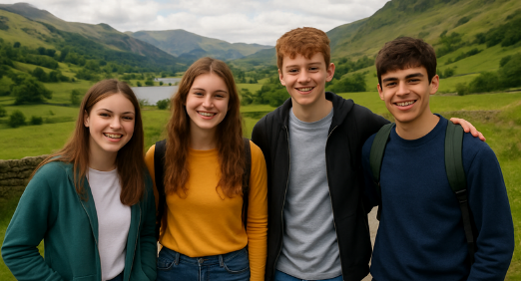
So we use IGetAround to just, you know, get around and hang out. It’s free for us which helps I suppose. It’s great that we don’t really need to plan much – we can just decide what were gonna do and use the app to work out how to get there.
Apparently it’s not long ago since we’d have had to buy a separate ticket for the bus or train or whatever, or go through that whole faff of trading chores at home for a lift from our parents. Well that’s all gone.
Getting to school’s pretty routine. We usually get the train cos it’s just easier, but if say we stay on in town after school, we’ll sometimes get the train or the bus back. ‘Cos Jake lives in Underbarrow, a load of us sometimes get the D2D with him then loop back to Staveley.

Next weekend, a load of us are off to Leeds festival. We’re got seats on the FlixBus that we booked as an add-on to the tickets, so it was only a fiver each way. We’ll use our accounts to get to Lancaster then pick up the coach from there.

Village based business

It was a cracking spring day so I ran into work this morning from Burneside. I knew it was going to be a busy day so got some exercise in beforehand. Having showers in the Millyard just makes being active so much easier, not just for us but for visitors too.
It’s Wednesday so it’s delivery day. The Millyard businesses bulk their last-mile deliveries that aren’t urgent from the Shared Logistics Hub, mainly because of cost (if I’m being honest), but also to limit the number of vans clogging up the roads. More urgent stuff either comes to the door or into the village MailHub.
I’m out seeing clients for most of the day – Ambleside. Keswick then a couple of stops out west. I’ve planned the Ambleside and Keswick meetings via the Lakes Express bus, then I’ll pick up an EV in Keswick to get to the outliers and drop it back off in Kendal later on. Ill book and pay for everything on my mobility account making sure I tick the box to charge it to the company. If I have time in the afternoon, I might take a bit of a detour for a swim in the Duddon.

Visitor accommodation
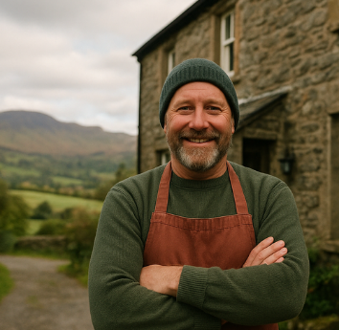
We opened the Staveley bunkhouse in response to the demand for a wider variety of accommodation types in the area. From rooms in the pub and a few guest houses, the village now boasts a seasonal campsite, bunkhouse expanded pub accommodation, 3 guest houses and the SpareRoom network has really boosted the village as a destination; it’s great to see the shops thriving as a result.
About half of our guests have been before and after the first visit, most now arrive by train or coach. Quite a few are booking the e-mobility add-on to their train ticket when they book their accommodation – so they hop off the train at Oxenholme and jump on to an ebike or e-cargo bike; quite a few are here for the cycling so pedal in from Oxenholme or get the train to the village with their bikes. I’ve seen the amount of stuff that some people arrive with on the campsite – and wonder if they are staying for a month!
Our guests really value the ability to get around. It’s always been fairly easy to get along the main Kendal-Keswick corridor, but the shared e-mobility options plus the D2D shuttles have opened up Kentmere, Longsleddale and valleys to the south to quiet exploration and totally changed the visitor proposition. On top of this, the combination of the Lakes GuestCard, cracking real-time info and mobility guarantee has made getting around really simple and stress-free – it means people can explore on their terms rather than being pushed to the easy-to-access honeypots. This is great for me as they stay longer! I especially like autumn as happy guests turn up with damsons and cheese that they have bought from the FellFarmVend points down the Lyth valley.
The Work Shuttle system has opened up a much bigger pool of staff for the whole accommodation sector in the area. As an employer with a need for staff early & late in the day, the ability to have a say in shuttle routes and timings with other employers has been a game-changer. It means I can access a much larger pool of staff compared to the old days, I have happier staff and therefore we have a much more stable workforce.

Playground users from Kendal & Windermere
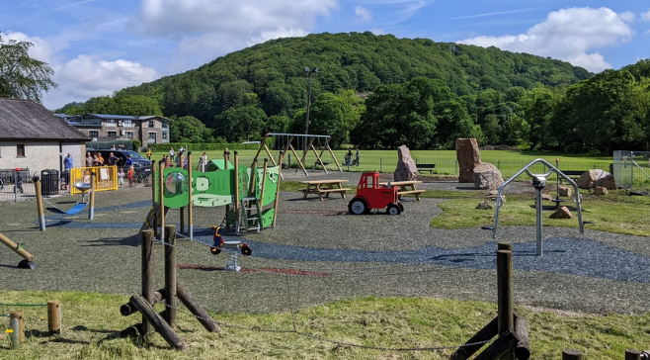
It’s easy for us to get for Kendal to Staveley these days. We hop on the train, take the lift down from the platform (my toddler, Josh loves pressing the buttons), and walk the completely flat kerb-free, uncluttered route from the station to the playground. Josh has a game where we have to sit on every parklet bench, so we’ve done a bit of a workout by the time we get to the playground. We meet up with playgroup friends from Windermere then head to a café.
On the way home, we take the 555 as Josh loves being on the top deck. We use our family mobility pass for all our journeys, so gone are the days of expensive 1-way tickets or being restricted to either the bus or train.

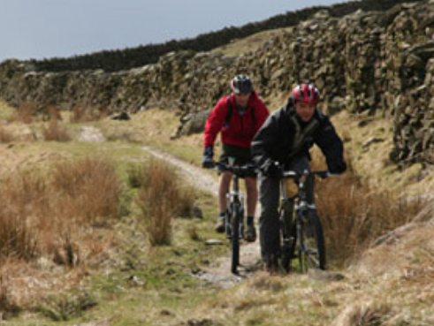
Weekend MTB mates
Joe and Mike started coming to Staveley mountain biking a couple of years ago. They used to come by car, but now mix either the car or train. When they came by car, they’d leave it at the visitor car park and head into the village to start the day poring over maps with a coffee before heading out.
This time, they decided to take the train. It’s direct from Manchester. Mike takes the lift from the platform, but as it’s quiet, Joe insists on bunny-hopping the steps(1). They leave the kit in the bunkhouse, then grab a coffee to work out a plan.
They take the bike shuttle up Kentmere to take off a few miles of tarmac. They use their LakesCard account on their phones – dead easy now its set to top-up automatically as they hammered it on the last few trips. They’ll probably pop out at Kirkstone or Troutbeck – either allows for a quick pint and two buses to get back to Staveley later.
It’s tea in the pub tonight, then see what the weather looks like tomorrow. Mike’s been poring over knitting together a load of tracks south of Staveley, so they might get the shuttle into the Lyth valley and weave their way back. But that’s for tomorrow.

Places
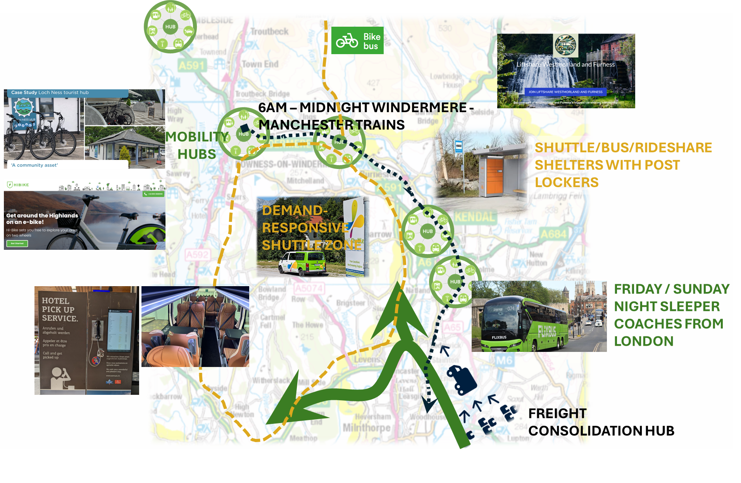

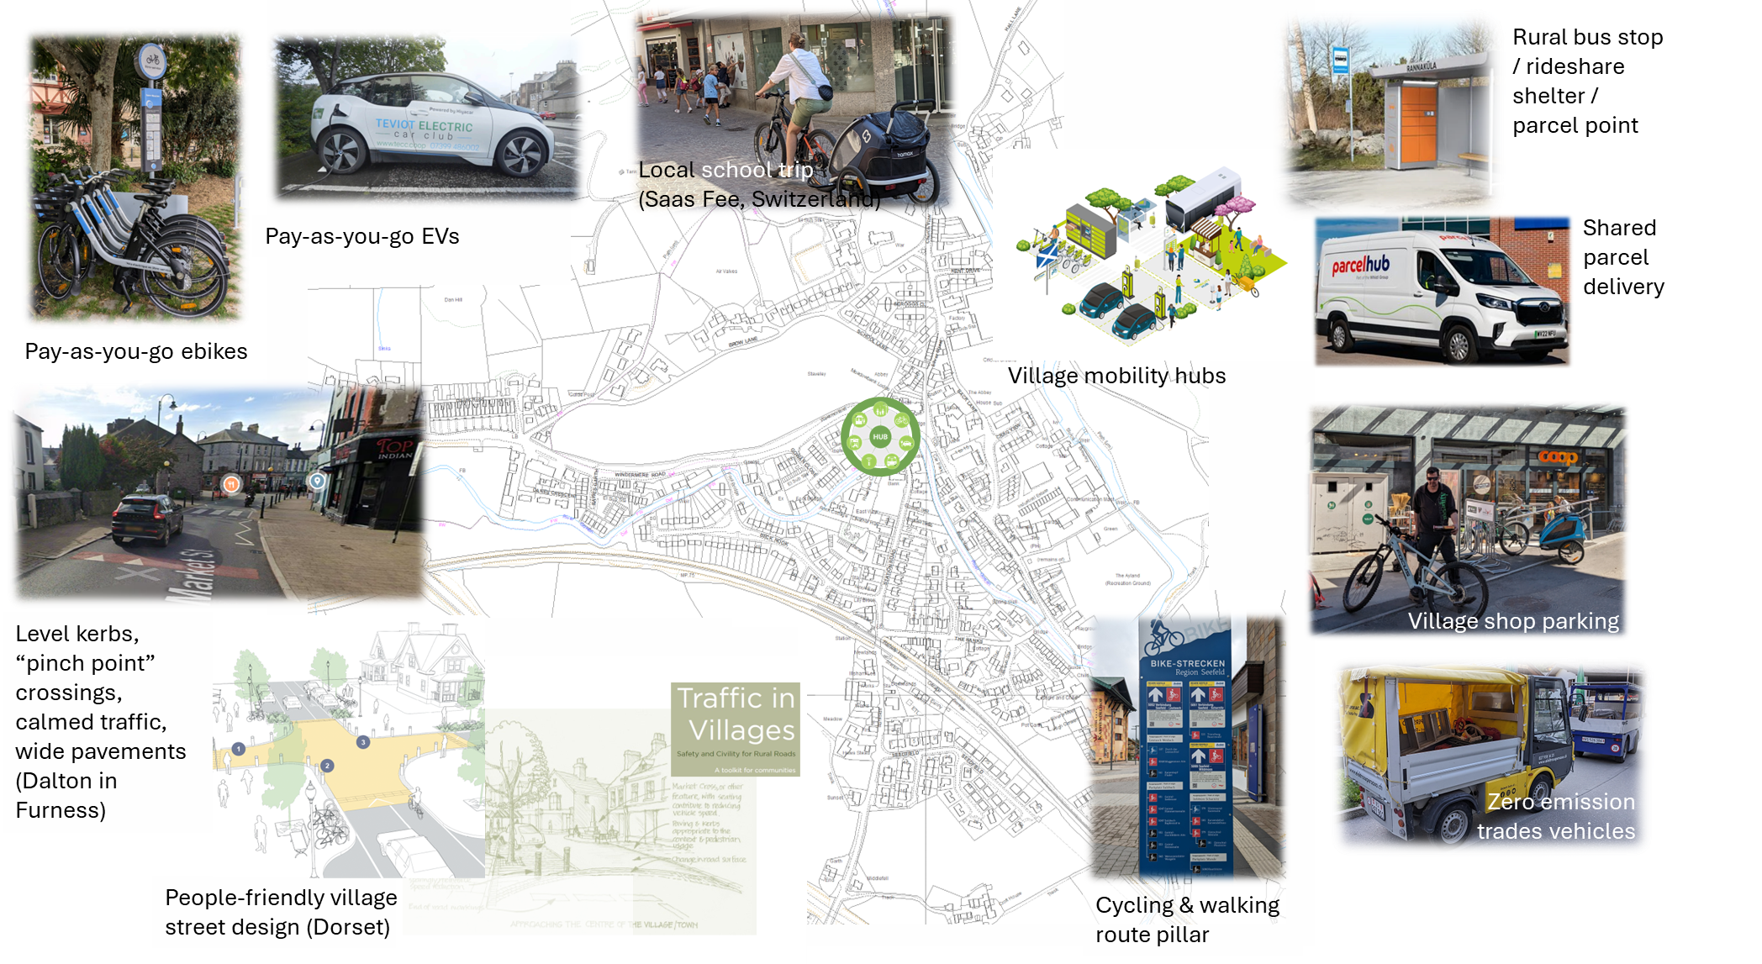

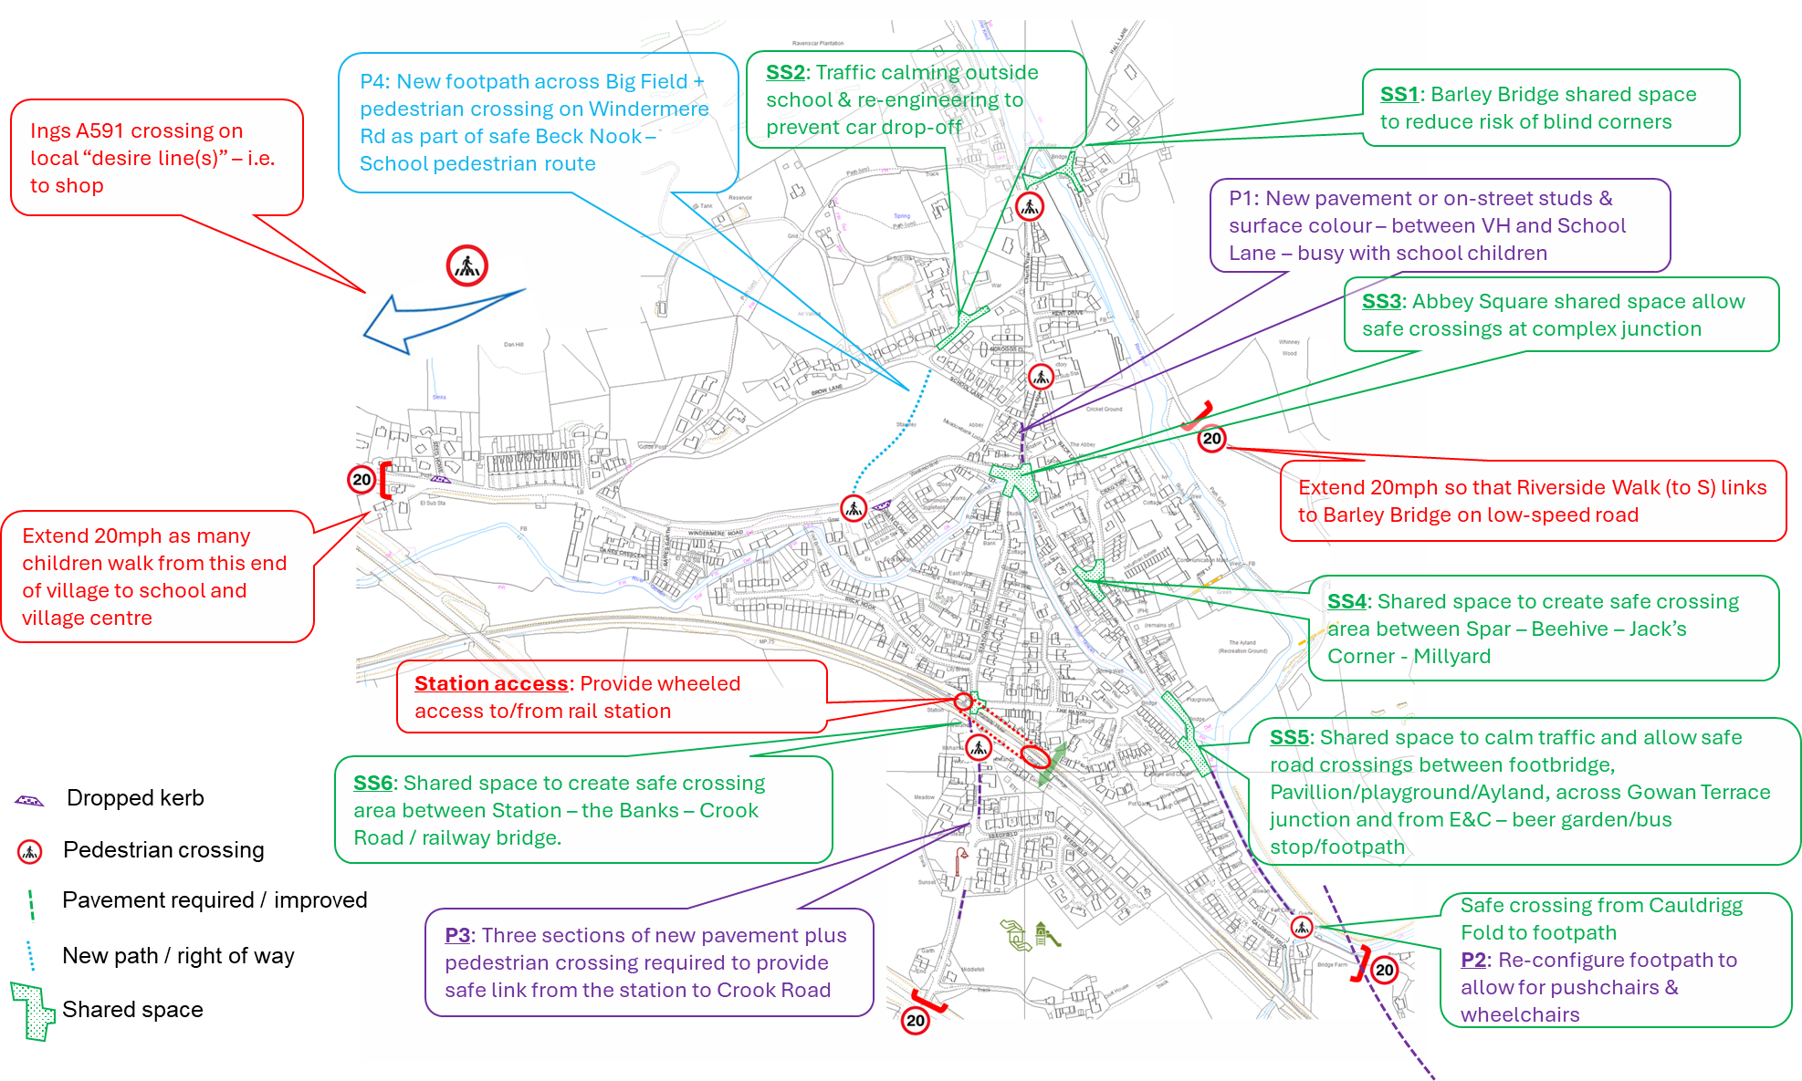
This shows the infrastructure recommendations that emerged via consultation in the I Get Around project¹². They are presented here to show more detail about how streetspace could be remodelled for people-friendly village places and lifestyles
Glossary
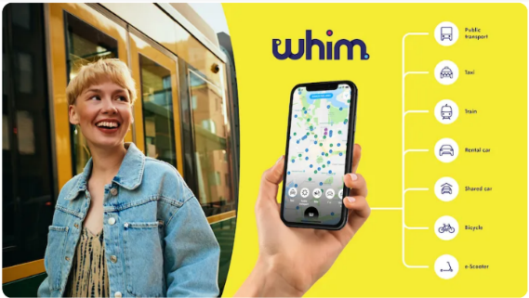
Mobility account
A variety of types of mobility accounts would allow people to access most forms of transport locally, including local bus and train with options to add on shared transport (EVs, bikes, ebikes etc). Different modes would be charged at different mobility unit “cost” to reflect their real relative cost. Accounts will be similar to mobile phones
- pay-as-you-go - where best-value fares are guaranteed in any 24 hour period (c.f. London’s Oyster)
- on contract where people buy different amounts of mobility (c.f. mobile data packages).
The account would enable: (i) costs for a journey to be attributed to e.g. an employer, (ii) costs to be split across a group (e.g. for sharing an car), (iii) supplements for e.g. occasional travel outside the area or for services not routinely included.
Mobility guarantee
As part of the mobility account, this would guarantee onward connections in case of disruption, such as providing a taxi to a destination if a late arriving train misses a connection. It would involve a degree of “reasonableness” – unacceptable wait times etc.
Mobility app & real-time information
A single app would bring together all modes of travel in the local area, including (i) real-time information, (ii) the ability to book services and (iii) link this back to the user’s mobility account.
Lakes GuestCard
A card that provides access to local travel from main access hubs into the local area for visitors. Based on those common in continental Europe, a basic card might be provided free with accommodation booking, and/or a paid card with different level of mobility options could be bought by visitors. Cards might be time-limited (e.g. 1 day, 1 week or length of stay) or will hold credit for repeat visitors.
Shared transport
Fleets of EVs, ebikes, e-cargo bikes and other e-mobility available as pay-as-you-go (following sign-up) or via people’s mobility accounts. Vehicles could be reserved in advance or used as turn-up-and-go if available.
Towns and most villages and hubs would have several EVs, ebikes and e-cargo bikes available for people with accounts to use as part of their mobility. It would be cheaper to use them if brought back to the start point, but can be used for 1-way trips within the designated areas for a higher charge.
Rideshare
Sharing lifts is made easier by widespread use of apps. This might be “open” – for anyone to share with anyone if the journeys match, “closed” – such as groups to get children to school or scouts, or semi-manual ring-around groups for people who don’t like or can’t use tech. Secure hitching works in rural areas overseas – bus stops double up as hitching shelters for local people to make local journeys (commutes etc) using an app to provide security.
Walking bus
Children join timed & led “walking buses” to access schools & youth groups (scouts etc).
People-friendly public realm
Town, village & hamlet centres are designed to make sure that it is safe and easy to move around by walking, pushchairs, wheelchairs etc. This includes wide pavements, “shared space” at junctions and popular areas, clear sight-lines, narrow-road pedestrian crossings. “Parklets” – i.e. mini-social areas with seating could be designed-in to the streetspace to enable people of limited independent mobility to rest as the made local journeys.
This wouldn’t exclude cars, but slower speeds would be “designed-in” to streetscapes. A hierarchy of car parking ensures access for those with mobility issues to key locations, but is designed to maximise quality of public realm for all, safety and to reduce “clutter”. There would be fewer cars parked in higher-footfall village centres; this would be compensated for by well-designed parking on the edges of busy villages – for visitors and residents with multiple vehicles and no/limited parking.
Mobility hub
A network of mobility hubs exists across neighbourhoods, villages and other key locations.
Mobility hubs bring together access to transport, including (as appropriate to the location) bus stops, shared transport (EVs, bikes etc), information (including real-time), wifi and safe, attractive waiting areas (e.g. for ride-sharing). Ideally, these would be designed-in as part of a village centre, co-located near to cafes, village halls etc.
They may also include delivery lockers including refrigerated lockers to allow for online shopping delivery.
MailHub
A place where delivery hubs of different delivery companies are co-located. Deliveries can be made to the hub or failed home deliveries can be left here. Mail hubs would exist in all village centres plus integrated into bus/rideshare shelters in rural areas.
D2D (Door-to-Door) shuttle
A smaller demand-responsive bus that operates on a loose route/zone and timetable, enabling pick-ups and drop-offs off route. Complemented by shared taxis/taxi bus for groups.
Work Shuttle
Bus services designed by employers to maximise access to workforce. These provide access from surrounding larger towns as well as from local villages at times that work for the busineses. Co-ordinating demand across employers makes economic sense.
Express bus
Fast, limited-stop buses along the A591 corridor (Kendal-Keswick) integrated into stopping services.
Luggage transfer
Pre-booked luggage transfer to/from the area as an add-on to longer distance transport ticketing.
Sleeper trains/coaches
Longer distance sleeper services on the WCML / M6 timed to be accessible from the local area
Worker-connect carriages on trains
Includes bookable pods for teleconferencing, meeting tables etc.
Shared logistics hub & bulked deliveries
Shared logistic platforms would allow for efficient deliveries. Large long-distance delivery lorries (from specific delivery companies) or trains would deliver to the hubs. Smaller trucks would aggregate onward “last mile” deliveries (regardless of operator) to specific locations such as Staveley. These trucks would take goods pick-ups back to the logistics hub.
Places would have less urgent shared delivery days. Deliveries would be made to the recipient’s address or to the MailHub.

Wrapping up & moving on

For PEAT and SENS…

For CSN?

For ZCC

Fore named ERAP agents for change

Appendix 1: Transport & Mobility ERAP interpreted for Cumbrian localities

Strategic Priority 1: No new infrastructure that will increase emissions (avoid)
ERAP Action |  | Comment | What does this mean at community scale?
T1.1 | Avoid new emissions from new highways capacity | No new roads - unless can be shown to result in net carbon reductions etc | Better maintained highways, pavements & paths with ££ re-directed from roadbuilding
T1.2 | Reduce local aviation emissions | N/A | N/A
T1.3 | Location of new developments to be approved based on sustainable transport accessibility and reduced car dependency | Housing and services located near to existing transport, & developments designed not to lock-in car use. | More housing closer to village centres; no new edge-of-settlement developments unless other options exhausted
T1.4 | Avoid indirect emissions from car parking. Car parking embeds car use; new car parks generate new car miles. | Use existing car parks better; shift to avoid new parking through smart design | No new car parking capacity without replacement - i.e. neutral overal parking
Strategic Priority 2: Reduce need to travel by car (substitute)
ERAP Action |  | Comment | What does this mean at community scale?
T2.1 | Spread the relatively high carbon approach journey from visitors over more in-destination days |  | More visitor accommodation: Hotels, guest houses, bunk houses, campsites
 |  |  | Create multi-day visitor propositions: meal & accommodation; multi-site gastro tours
 |  |  | Stable jobs from expanded local visitor economy
T2.2 | Re-localise services to improve access to day to day services through active travel. |  | More service sand shops in villages; less need to travel to nearby towns
T2.3 | Enable home & flexible working as the default way of working (for those organisations for which it is appropriate) |  | More vibrant daytime village centres; more shops and cafes open throughout the week/year; more informal socialising; denser local professional networks
T2.4 | Optimise logistical efficiency of delivery van journeys in rural areas. | Reduce inefficient single-operator last0mile systems and reduce failed deliveries | Fewer white vans on rural roads; added prupose to hubs acting as delivery hubs; opportunities for local "last mile" delivery busiunesses (small ZEVs, e-cargo bikes etc)
T2.5 | Capture efficiencies across sectors and operations via transport sharing: "Total Transport" | Share vehicles, journeys and systems across NHS, schools, public, community transport, shared transport etc | More flexible and dynamic transport options within the local area
T2.6 | Look for opportunities to offer meaningful collaboration, education experiences and knowledge sharing through delivery of carbon literacy training with a longer term engagement pathways. Targeting employers/Eductation/Community/Youth organisations. | Businesses more aware of what "good" looks like & have appetite to be part of solutions | Offices, shops etc have near-door bike & e-mobility parking, delivery services; better near-building people-friendly landscape with fewer cars
Strategic Priority 3: Travel better (shift)
ERAP Action |  | Comment | What does this mean at community scale?
T3.1 | Development of new Local Transport Plans that have a vision for decarbonised travel:  - redefine the role of active travel through expanding infrastructure provision within and beyond towns and the city centre  - Support the reallocation of road space to cycling, walking and public transport  - Support expansion of shared mobility schemes (e.g., car clubs)  - Support electric vehicle uptake
T3.2 | Have low carbon transport services for visitor/business inbound/outbound destination activity
T3.3 | Design places for low carbon access and transport | Local places more people-focussed | Safe, calm village centres; humdrum/chatter and informal socialising replaces car parking; lanes and smaller roads feel calmer and safer; less congestion / more reliable journey times
T3.4 | Targeted access restrictions | Access to places by need | No rat-running; safer residential streets
T3.5 | Deliver a strategic county-wide integrated public transport system for residents, businesses and visitors. |  | Ability to get to where you need to go, when you need to get there. Mixture of scheduled and on-demand options.
T3.6 | Simplify public travel through single county travel passes & ticket purchasing system |  | Local mobility passes - provides packages fo local transport for different types of local people & visitors
T3.7 | County-wide cascade of mobility hubs  Mobility hubs bring together transport & access services with other appropriate services and facilities | Visible network of places to access transport | Rail stations: Rail / bus / bike/ebike/e-mobility share/pick-up: Grange, Hest Bank, Cark stations
 |  |  | Village centres/shops: Bus, EV share, bike/ebike share/rent: Grange, Kents Bank, Cark, Cartmel, Allithwaite, Lindale; Staveley village centre, Ings
 |  |  | Key junctions: waiting areas and live information; e-mobility hub; taxi pick-up
 |  |  | Neighbourhood hubs:
 |  |  | Isolated bus stops: shelter, smart lighting, printed info & wifi, real-time transport info
T3.8 | Develop options for alternative approaches to first/last mile travel | Getting from stations & main bus stops to destinations | bike/ebike /emobility - share schemes; taxis as part of Community travel cards; clarity on taxi costs; pre-bookable dmeand-responsive transport
T3.9 | Develop and adopt rural accessibility standards across the county to inform appropriate transport services |  | Appropriate transport services available to all wherever they live
T3.10 | Develop targets for mode share splits for a range of different situations including large employers and traffic intense destinations.  Use TfN North West target as a starting point:  Trips made my public transport increase from 8% to 15%,  Active modes increase from 29% to 36%.  Zero overall increase in travel demand on the road network by private car. |  | Travel not by car becomes normal out of choice because its better
T3.11 | Take a strategic whole-county approach to increasing walking & cycling for active travel with a target for walking and cycling to account for 50% of short journeys in Cumbrian Towns by 2037 |  | Walking, cycling and wheeling is the obvious choice for local journeys for many people; Healthier lifestyles
T3.12 | Shared transport service networks  Shared transport complements and extends the reach and functionality of public transport and active travel | Car clubs  Bike & e-bike share  Sharing lifts | Neighbourhood pay-as-you-go Evs < 5 minutes walk from people living in villages  Bikes & ebikes available to use through bikeshare, try-before-you-buy and loan schemes; micro-emobility (Trampers, ebikes, e-cargeo bikes, e-quads etc) available via main hubs  People in different social networks and groups (WI, scouts, sports & events, commute etc) share lifts routinely through easy matching systems
Strategic Priority 4: Make travel cleaner (improve)
ERAP Action |  | Comment | What does this mean at community scale?
T4.1 | Develop a strategy for accelerated take up of electric vehicles (EV) for personal use and car share/taxi fleet/pool cars – accounting for 75% vehicles on the road by 2030, and 96% by 2037 | Most cars electric or other zero-emission | Zero emission vehicles are easy to access by most people shared (car clubs,emplyee pools) or owned
T4.2 | Buses (Public Transport) and Public sector fleet (Police, NHS, Fire, Waste) decarbonisation | Most trucks & buses zer/low emission | No more stinky exhaust; quieter living
T4.3 | Shift to electric or hybrid rail network |  | Direct trains to more destinations on the mainline network
T4.4 | Investigate opportunities for low emission alternatives for freight and logistics including shift to rail.
T4.5 | Create grant scheme for ebikes & emobility |  | Easy to buy bikes & ebikes for some people
T4.6 | Promote fuel efficient driving to individuals and businesses and review speed limits on all highways with a view to reduce speed limits where appropriate for emission reduction impact. |  | Slower speeds leading to safer roads; people become better drivers

Appendix 2: Transport recommendation of the climate juries in Furness, Kendal and Copeland

Furness⁸
We need investment in cycling infrastructure and cycle paths to encourage more people to cycle. This should be done by:
- cycle lanes and road surfaces being clearly marked and well maintained (road surfaces and cycle lanes require different surfacing materials). We should lobby for extra funding for this.
- better mapping and showcasing of existing and future footpath and cycle routes and links to encourage use. This should be made as simple as a tube map on a board, or like the routes around Grizedale.
- the council converting more footpaths to bridleways to be used for cycling.
- secure places for bike storage to encourage cycling.
- raising awareness in Furness of cyclists’ rights to be on paths and roads.
- enabling cycling between Barrow, Dalton, Ulverston and beyond with minimal interaction with traffic, using segregated routes.
- the council making sure that encouraging electric bike use for medium journeys should be included in transport plans.
The local Business Improvement District should be encouraged to focus their membership and wider business community to actively promote low carbon travel options for their employees. This could include an electric vehicle fleet funded by larger businesses to offer coordinated transport options for people getting to and from work. The use of electric bikes could be more widely promoted and financially supported for employees by businesses.
Bus services should be made more appealing to encourage the use of public transport. This should be done by:
- increasing the frequency on routes that are busy
- implementing bus routes in areas that get insufficient service.
- The allocation of more bus passes for local residents.
- advertising and educating residents about bus pass availability, bus times, and ticket types to increase awareness of available options for public transport in Furness.
- investing to replace large and double decker buses with more frequent smaller, efficient or electric people carriers. Routes could then also be expanded to include rural communities currently not accessible by large buses.
- ensuring that local timetables connect/link with other forms of transport
Businesses and transport providers should work together to encourage the use of public transport by offering an incentive and increasing services at certain times. If people buy a multi-trip bus ticket (e.g. a day rider or monthly pass), they could also receive a discount card for local participating businesses. This could include discounts at shops, or perhaps a free meal in a restaurant. Bus services should also increase in line with offers within the discount card (e.g. later evening services to improve night-time economy etc). Staff of participating businesses could be offered free bus travel in return.
This jury urges the Council to commission a report setting out a vision of what a low-carbon transport system for Furness (including links with surrounding areas) could look like based on best practice elsewhere (with citizen input). Achieving such a vision would reduce climate change impacts, enhance local prosperity by creating business opportunities and increase choices in work and leisure for a wider range of people through improved transport options.
To achieve this vision our recommendation is that council should directly employ an officer/s with knowledge and experience about low carbon transport who can lead the transition to low carbon travel and inspire the public and businesses as a key part of the process.
The cross-party support of Council members is vital to ensure action. This vision should include non-car connectivity with the Lake District and local coastal areas (taking into account desirable end points, target markets, which organisations might lead on development and delivery etc. with a view to trialing different initiatives ahead of new local government reorganisation in 2023).

We should encourage more people to walk by:
- implementing schemes to incentivise walking to school such as through discounts, subsidies for trainers, good shoes and protective clothing. We can also organise a local walking / running competition to schools or workplaces for a term or more, with gym / PE equipment / similar as prizes.
- Providing facilities for runners, walkers and cyclists (including at workplaces) for changing and showering, with storage space (such as lockers or hanger space) or a dry room to dry clothes.
- Incentivising children to walk to school, for e.g. through stamps on a card. This might also encourage parents to help them to walk to school.
- Overhauling of traffic light signal priorities to benefit pedestrians and road users alike by making them smarter and more time efficient.

We should have a bus service that is either free or heavily subsidised. Before local government is reorganised, the council should investigate how this can be paid for without causing low-income households to bear the cost through taxation - some options could include a tourist tax or a contract workers tax. Other options could include: free bus services for locals who meet the criteria of local occupancy in Furness, or at least 1 free return bus journey per day.

A system should be created to share or coordinate shopping deliveries from large supermarkets/businesses to reduce the need for individual vehicles to go out shopping and promoting local produce with reduced food miles.

Kendal⁹
Local public transport system
We must improve the local public transport system in particular – buses, ensuring bus travel is affordable, frequent and reliable for all users. This could be achieved by:
- Taking all bus routes back into public ownership. Bus routes must not be at the mercy of whether or not they are profitable.
- Providing subsidised bus routes
- bus passes for young people being much more widely publicised to encourage young people to use the buses.
- Improving the provision of bus shelters on Kendal town bus routes to encourage year-round use of buses for short distance trips. Where possible, rural bus shelters should have provision for secure bicycle parking allowing users to cycle to the bus stop.
Improved cycling provision
We must shift the priority from cars to an infrastructure that prioritises pedestrians and cyclists. This will reduce car usage so reducing emissions and congestion To achieve this we must think imaginatively: we must make it easier for more people to take up cycling as a form of transport. We must increase opportunities for those who cycle, or those who could be encouraged to cycle, by:
- Greatly improving and extending cycleways in town (and through connections with other towns). People don't feel confident to use the existing cycle routes. People must feel safe to be able to take up cycling and free up the roads from cars.
- Investigating the feasibility of an ebike hire scheme.
- Providing more secure, sheltered storage for bicycles in Kendal.
- Examining where it might be possible to give cyclists priority over motor vehicles.
- Making sure such changes include a comprehensive awareness raising and promotional campaign
There needs to be a practical vision for cycling in Kendal guided by Kendal residents and local business and organisations. Local councils must commit to work with this vision to make it a reality. They must draw on other examples from around the world to make sure that increased cycle provision does not discourage people who choose to walk as a form of transport by segregating motorists, cyclists and pedestrians wherever possible.
Traffic reduction
We must further reduce the volume of traffic in town and the surrounding area through:
- Encouraging car sharing - Kendal Town Council should facilitate a car sharing website with appropriate security to enable commuters or people travelling for shopping or leisure in and out of Kendal to connect and reduce individual car journeys.
- Investigate a feasibility study for a Park and Ride scheme for Kendal town centre and for the Lakes.
Electric Cars
Kendal should promote the use of electric cars by facilitating the installation of more charging points on street, in public car parks and car parks owned by local businesses. Local councils should lobby government to provide incentives for people to change to electric vehicles and disincentivise the use of petrol and diesel vehicles.

Copeland¹⁰
Cumbria needs an overall transport policy that addresses climate change urgently and with enthusiasm. This will incorporate the best parts of developments in other counties with a similar geographic configuration. We want the council to listen to leaders in the field of climate change This will be driven by a dedicated team with an inspired leader who can be held accountable to the people of Cumbria. Performance criteria must be publicly communicated widely and outcomes independently verified, with the use of active and targeted feedback mechanisms. These changes will be cascaded to enable urgent change for Copeland.
This policy must start immediately and proceed imminently regardless of the outcome of the Council reorganisation. This will ensure and enable the effective implementation of the other transport recommendations made by this panel.
We need a plan (with time scales) for an ambitious, integrated, regular and affordable public transport system. It must be:
- available for all and regularly connect all our villages and not be based upon profit and should be in public ownership. Whoever provides our public transport services must recognise that they have an obligation to serve our communities.
- regular and frequent (including earlier and later buses and trains) and stop at more places.
- well publicized so people are aware of what is available and service information and timetables are regularly updated (e.g. a real time app with live updates).
- an affordable system, at least some bus lines should be free. We recognise free buses is an ambitious plan and recommend a) more work should be done to investigate how this can be funded b) we should experiment with this approach e.g. a free bus summer.
- modern (using latest technology) Such a system will also serve to enhance local quality of life by
- enabling us to travel between communities (for work and leisure) and bringing tourism to the area (e.g. walks linked to trains and buses) as well as reducing carbon emissions.

In any future road building or widening schemes, consideration must be given to whether the purpose of these plans fits in with the climate change agenda, consider whether the proposal will lead to increased CO2 emissions on the road network and consider whether this is the best use of public money, asking for input from the community where possible
We must make it easier for people to be able to cycle as much as possible. Effort must be made to change the mindset from seeing cyclists as a problem. This should include:
- Education: so that drivers are more aware of cyclists and cyclists do not disrupt traffic.
- E-bikes: an e-bike scheme for Millom to Barrow in Furness and efforts to plug gaps in the infrastructure
- network where people have last or first mile issues getting to work.
- Increase awareness of what is available: e.g. more signs for where bike tracks are. A cycling in Copeland website
- or app and maps
- Encouraging cycle to work: Shower facilities where you work and bike storage in more places.
- Better links to public transport and more space on buses and trains for bikes.
- Better lighting and maintenance of cycle paths.

We must make it as easy as possible for people not to use the car. We must increase the quality and availability of alternatives to car use. There should be an investigation into the idea of introducing a tourist levy to pay for these alternatives. Such an investigation must consider, what amount the levy should be, how it could be administered and how to ensure that the money generated goes to the right places.
We must reduce car journeys to school. Schools should be surrounded by no car zones or at a minimum 10-20 mph speed zones.
Cumbria should be ready for the implementation of a hydrogen (fuel) strategy. The potential for hydrogen should be actively explored

Appendix 3: “So what might low carbon transport involve around here?” slides from Grange workshop

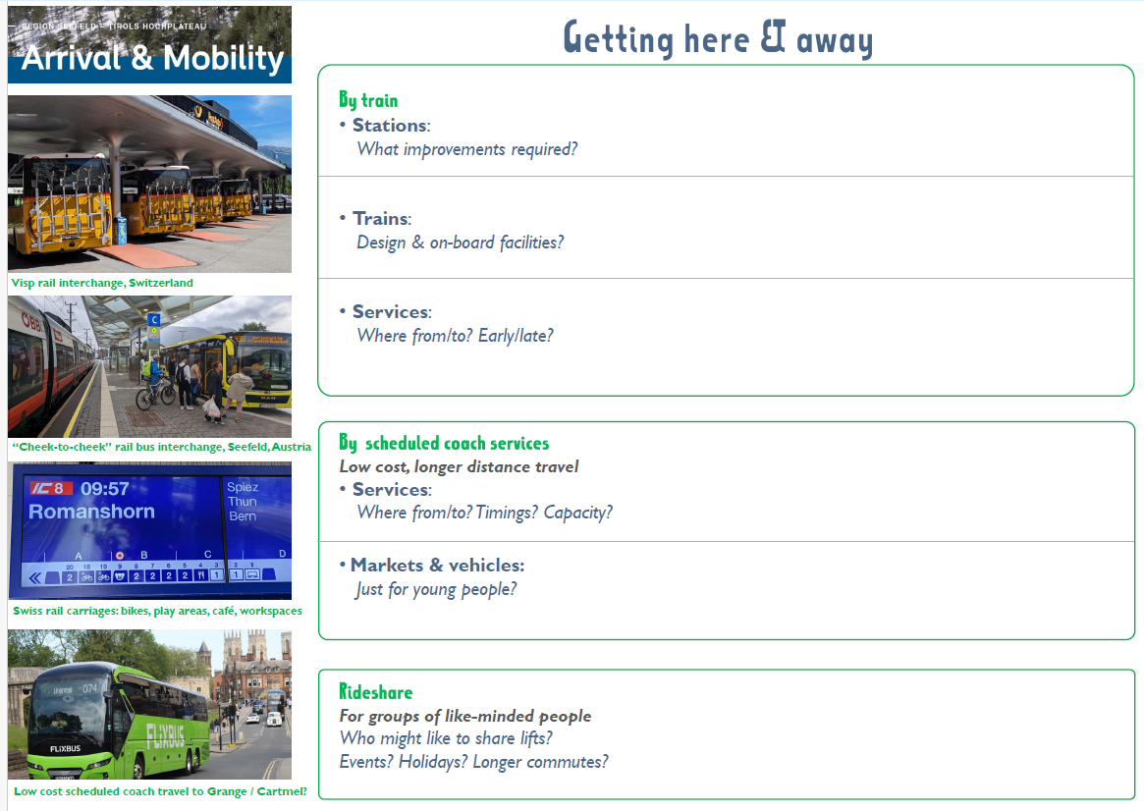
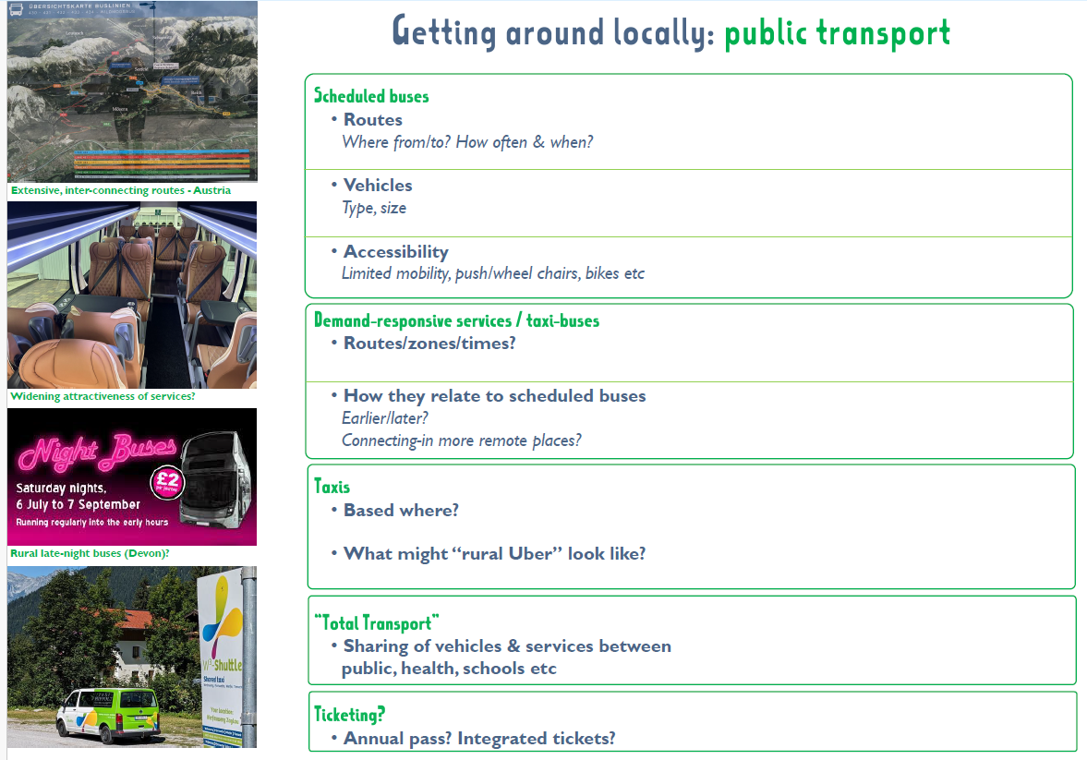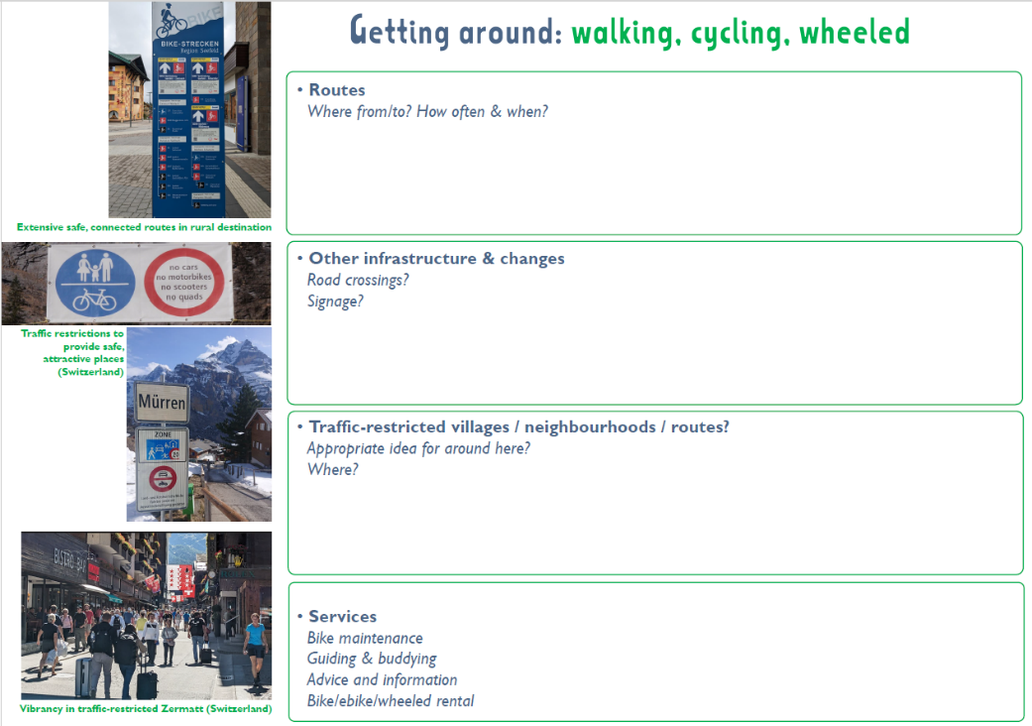
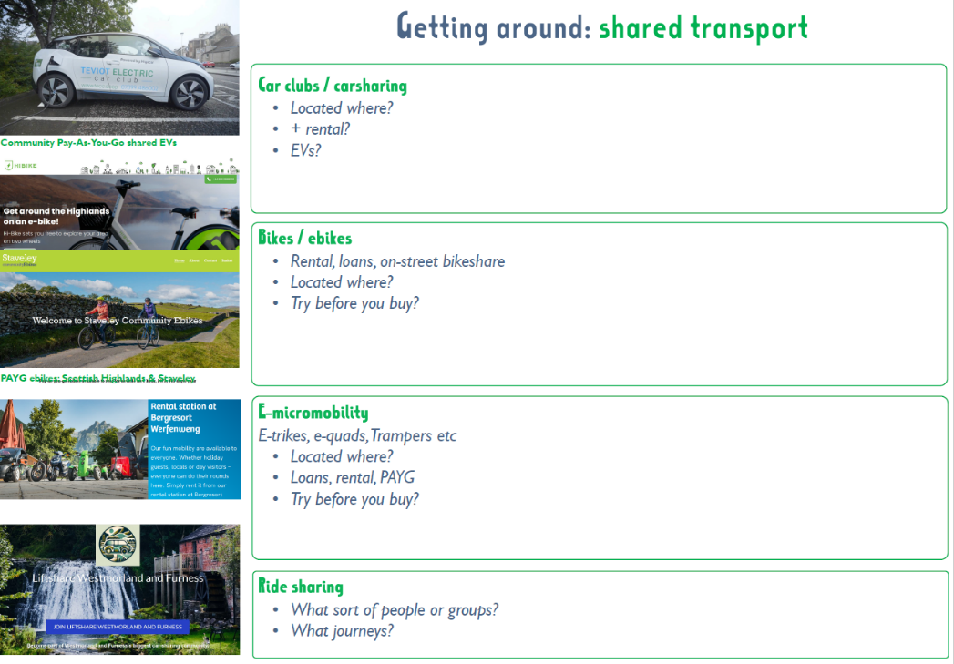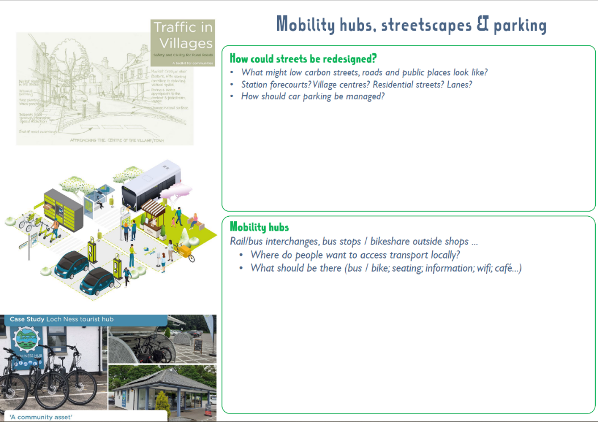

Visitors staying longer helps to reduce carbon – as they get more lower carbon in-destinations days for the higher-carbon journeys from/to home.
Climate Change Committee Seventh Carbon Budget (February 2025); https://www.theccc.org.uk/publication/the-seventh-carbon-budget/
Small World Consulting (2020), A Carbon Baseline for Cumbria, https://cumbria.gov.uk/elibrary/Content/Internet/536/671/4674/17217/17225/4414012219.PDF
Wamsler, C, Mundaca, L. & Osberg, G. 2022 Rethinking political agency: The role of individuals’ engagement, perceptions and trust in transitioning to a low-carbon transport system, Journal of Cleaner Production (360); https://www.sciencedirect.com/science/article/pii/S0959652622018030
Frost S (2025) Fairer is faster: The route to greener and healthier domestic transport, IPPR. www.ippr.org/articles/fairer-is-faster
https://www.peatsouthlakes.net/home.html
http://www.sustainablestaveley.org.uk/
https://zerocarboncumbria.co.uk/wp-content/uploads/2024/02/ERAP-Transport-and-Mobility.pdf
Based on ambitions from a variety of places (https://transportforqualityoflife.com/wp-content/uploads/2023/11/211214-the-last-chance-saloon-to-cut-car-mileage.pdf): - Scotland: 20% reduction2019-2030 (https://www.transport.gov.scot/our-approach/environment/20-reduction-in-car-km-by-2030/) - Wales: 10% reduction 1990-2040 (https://www.gov.wales/llwybr-newydd-wales-transport-strategy-2021-html ) - UK: - CREDS (Centre for Research into Energy Demand Solutions) estimates that a 30-50% reduction in total car mileage is needed by 2030, relative to 2020 https://www.creds.ac.uk/transport-mobility/ - Green Alliance: 20% by 2030 (c.f. 2023) (https://green-alliance.org.uk/wp-content/uploads/2023/04/Moving-on-greener-travel-for-the-UK.pdf)
Government target of 800,000 public EV charge points by 2040 (https://static-files.nationalwealthfund.org.uk/s3fs-public/download/UKIB-Strategy-Update-EV-Charging.pdf) compared to 82,002 in July 2025 (https://www.zap-map.com/ev-stats/how-many-charging-points)
From Bus and Coach: The route to net zero (November 2022) by WPI Economics for the Confederation of Passenger Transport; https://www.cpt-uk.org/media/h15b0o2j/01-wpi-economics-cpt-the-route-to-net-zero-exec-summary.pdf
Moving on: Greener travel for the UK, Green Alliance, 2023. https://green-alliance.org.uk/wp-content/uploads/2023/04/Moving-on-greener-travel-for-the-UK.pdf
https://sharedfuturecic.org.uk/wp-content/uploads/2024/04/The-peoples-climate-panel-Copeland-2021.pdf
https://sharedfuturecic.org.uk/wp-content/uploads/2024/04/Climate-Jury-Kendal-2020.pdf
https://sharedfuturecic.org.uk/wp-content/uploads/2024/04/The-peoples-climate-panel-Copeland-2021.pdf
https://www.cumbriaaction.org.uk/news-events/news-appetites-to-travel-differently-in-the-lake-district-where-do-you-want-to-go-reports-available-now-2024-05-15
A community-led WFC funded project to explore via public engagement barriers and possible solutions to “getting around” the locality; http://www.sustainablestaveley.org.uk/2025/04/i-get-around-a-study-of-community-needs-to-get-around-staveley-published/
https://www.staveleywithings.org/community-plan
https://www.communityebikes.org/staveley/
https://www.surveymonkey.com/r/GNFVNYY
http://www.sustainablestaveley.org.uk/our-projects-old/past-projects/staveley-green-travel-initiative/

